Aaron Shaneen

CS3550 ONL

Assignment 1

Jan 20, 2016

**Exercise 1**

A.) No, payments must be associated with one and only one customer. No, a single payment cannot be made for two customer’s invoices; however a customer can have multiple invoices and payments.

B.) Yes, fortune tellers can have multiple mentors or no mentors at all. And technically, yes, as per the database, a fortune teller could be their own mentor.

C.) Yes, a session can have no or multiple predictions made within that session.

D.) No, a session can involve one and only one customer, and one and only one fortune teller.

E.) No, a customer can only have one address on file. Yes, a customer can also choose to have no address on file.

F.) Yes, it is possible to know what prediction was made for what client and by which fortune teller as the prediction can only point to one and only one session, which can point to one and only one fortune teller, and also point to one and only one customer. However, the method for that particular prediction cannot be specified as no or multiple methods could be used by each fortune teller and those methods are not connected to the session or the predictions made within those sessions.

G.) No, a particular session cannot be identified with a specific payment. A session can have one and only one customer, but a customer can have multiple payments and multiple invoices. Likewise, a session can have multiple billable items, which will all show on one and only one invoice.

H.) When preparing an invoice for a customer the system could tally all billable items under one and only one invoice for one and only one customer for which multiple payments could be made. Yes, an invoice could be sent to a customer specifying which session the bill is for as all billable items can point to one and only one session.

I.) Yes, Madame Z can specify how much each fortune teller earns as all billable items point to one and only one session, which in turn point to one and only one fortune teller. Yes, Madame Z could pay fortune tellers only when customers pay their invoices, however specifying exactly how many billable items were paid could be slightly difficult as customers can make multiple payments for multiple invoices. So if a customer has five invoices but has only made three partial payments, figuring out exactly how many billable items were covered and for which sessions involving which fortune tellers could become problematic.

J.) Yes, the relation between Session, Billable Item, Invoice, and Customer is a four way relationship that would need to be broken up with an associative entity.

**Exercise 2**

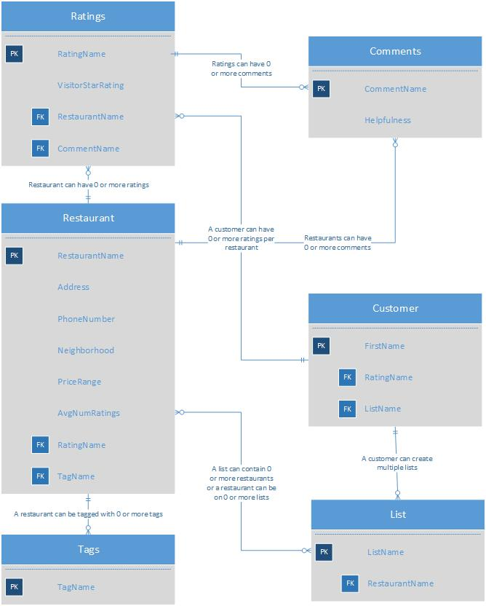

**Exercise 3**

